Case Name: |  |  |  |  |  |  |  |  |  | Date:
Abuse Report number:
Children |  |  |  |  | DOB |  |  |  |  |  | Placement/Caregiver

List ALL Parents , & ALL Caregivers |  | Phone Number |  | Address
Current Abuse Allegations
Prior Abuse History/Relevant Criminal History

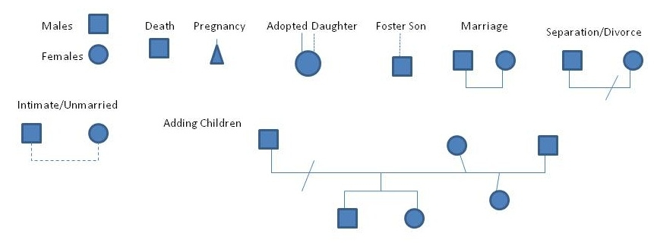 Genogram
Grandparents

Parents

Children

Case Discussion / High Risk Screening
SDM Risk Level: ____________________ N/A ________

Developmental Stage of the Family
Beginning Couple  Infant Preschool Family  School-age Family  Adolescent Family | Launching Family  Post-parental Family  Divorce and Remarriage  Other: ____________________________________________

Family Strengths/ Protective Factors(Nurturing and attachment, Knowledge of parenting and child and youth development, parental resilience, social connections, concrete supports for parents)

Exception Exploration (When doesn’t the problem occur? What keeps it from getting worse? , When has the client been in a difficult situation and found a way to avoid it?)

Outcome of Investigation (1) What everyday life task(s) is the family having difficulty with? (2) What are the details of the family interaction managing these tasks? (3) How do the key individuals in the family fail to do their part?

What is the family’s perception of the issue/concern? (Consensus on Issues)

Family Level Issue

Individual Level Issue
Safety Planning / OOHC Planning: (What safety actions have the family put in place? What additional safety planning with the family is needed? What transition considerations need to be addressed for a child in out-of-home care?)

Summary of Staffing Discussion/ Outcome of Staffing

Legal Determination and Rationale for Decision
Attorney in attendance:

Immediate Case Actions/  Urgent service needs to mitigate removal/ risk |  | Person Responsible |  | Date to be Completed
Additional Service Needs to Be Addressed at FTC/CPS
Early Engagement: No Yes Date::___________________

Staffing Participants |  | Agency |  | Title

