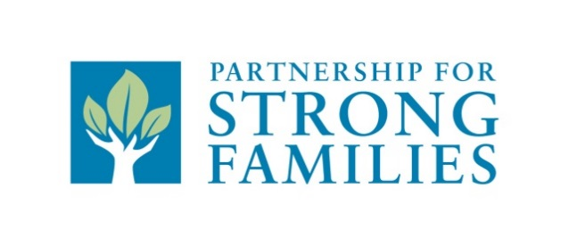

CONTACT: Stevie Doyle
Director of Communications and Engagement
Stevie.Doyle@pfsf.org
352-359-8169

Patricia Carroll

FOR IMMEDIATE RELEASE
March 2, 2021

Northstar family resource center
GRAND OPENING & RIBBON CUTTING
Lake city, Fla – The NorthStar Family Resource Center (NSFRC) will have its grand opening and ribbon cutting on March 18th, 2021. Partnership for Strong Families will hold this event in partnership with The Lake City Chamber of Commerce. The NSFRC is located on the property of the Richardson Community Center in the Ferguson Building. NSFRC will provide a wide-range of free services for community members of all ages including, but not limited to: academic assistance for K-12 students, emergency food assistance, faxing, computer access, employment resources, support for senior adults, and connections to other community resources. These services are provided in partnership with other social service and community serving agencies in Columbia County. Our goal is to provide centralized services where the surrounding community can access services before or during crises.
The grand opening ceremony will be led by Philip Mobley, Manager of NSFRC, Stephen Pennypacker, President and CEO of Partnership for Strong Families, Argatha Gilmore, Police Chief for Lake City Police Department, and other community leaders. “I applaud the investment that the NorthStar Family Resource Center will have in our community,” said Lex Carswell, Superintendent of Columbia County Schools. “I love the fact that it is located at the Richardson Community Center and will provide a wide range of free services for community members of all ages. We at CCS look forward to working with NSFRC to create a better path for our students!”
The NorthStar Family Resource Center is partially supported by the Community Collaborations to Strengthen and Preserve Families federal grant from the Administration for Children and Families’ Children’s Bureau awarded to the Partnership for Strong Families.
NSFRC will be the fifth in PSF’s network of Resource Centers, with additional locations in Gainesville and Chiefland. Each center evolves to meet the specific needs of the community it is located within and strives to involve community members in guiding decisions. “From the creation of the first resource center in Gainesville in 2009, PSF dreamed of expanding the resource center model across our entire catchment area,” said Stephen Pennypacker, CEO of Partnership for Strong Families. “Columbia County and Lake City being the second largest population center that we serve, we are excited to finally be able to bring our dream to life.”
To learn more about Partnership for Strong Families, visit www.pfsf.org.
###
About Partnership for Strong Families:
Partnership for Strong Families is the lead community-based care agency for Florida Judicial Circuits Three and Eight, including Alachua County. PSF is contracted by the Florida Department of Children and Families to deliver comprehensive child welfare services to children who are victims of abuse and neglect. Partnership for Strong Families also works with at-risk families to prevent child abuse and to decrease the risk of children entering the foster care system. PSF serves more than 5,000 children in 13 counties annually.

