**PARTNERSHIP FOR STRONG FAMILIES**

**STRATEGIC PLAN**

**2020-2021-2022**

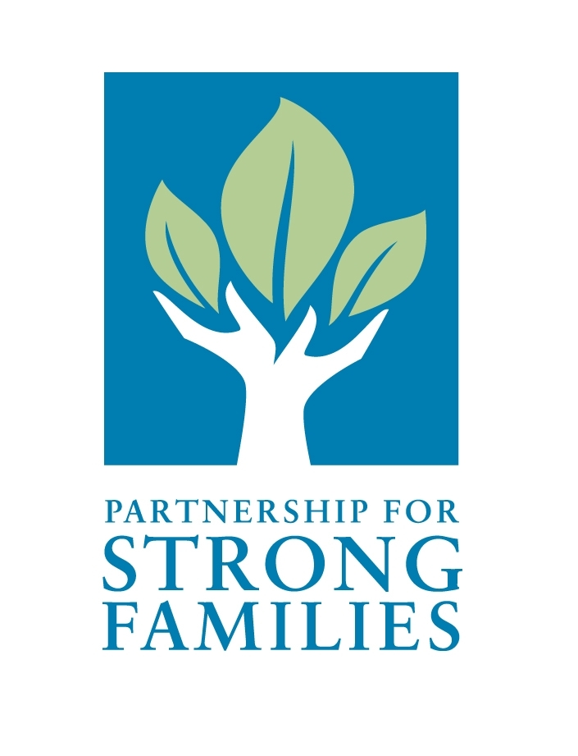

**PSF STRATEGIC PLAN: 2020-21-22**

**Executive Summary**

I have served as CEO for Partnership for Strong Families since April 2014, through the completion of two previous strategic plans. The first plan was well underway when I stepped into the Chief Executive position, with many goals already achieved; thus my role was to simply ensure the agency maintained focus on those remaining. The second, Strategic Plan 2016-17-18, was developed under my leadership and I am proud to have served as an instrumental guide in that process. Along with executive leadership and board members, we embarked upon many ambitious and innovative initiatives achieving numerous strategic goals and objectives by the plan’s expiration. This included arguably the largest goal to-date of expanding our corporate structure, providing vital sovereignty to grow our resources and better serve families in our community. In 2018, the board decided to expand this plan through 2019 to continue making progress toward our goals.

WatermarkOne of the strengths of our community-based care system is the ability to create solutions with our local communities that are responsive to our area’s specific needs. While we advocate for change through state workgroups and other collaborative partnerships, ultimately it’s up to our local team to resolve issues in order to immediately impact our system of care. Thankfully, our agency and dedicated network of providers and stakeholders are innovative individuals who work hard to develop new solutions to systemic issues within child welfare.

Strengthening external partnerships is an ongoing goal of ours, as we deeply understand that innovative practice is a direct result of shared efforts – our local system of care is much bigger than our agency alone. In fact, increasing community collaborations has been the backbone of each PSF strategic plan and remains so for the next three years. Together, we can continue building strong families and communities.

Please join us in this mission.



Stephen Pennypacker, Esq.

President/CEO

**Organizational Description**

Brief History

In 1998, the Florida legislature mandated that all foster care and related services be privatized, or provided through contract by private, non-profit agencies across the state. This transition was to begin in January, 2000 and be completed over a three-year period. The concept was dubbed Community-Based Care (CBC), with the intent of building a stronger, more effective system through a community-driven process that was to be advocacy-based, locally organized and empowered. The initial contract between the Department of Children and Families (DCF) and PSF was signed on June 29, 2003. Since that time, PSF has been the lead agency for child welfare services in North Central Florida, providing comprehensive services for Judicial Circuits 3 and 8, which consist of Alachua, Baker, Bradford, Columbia, Dixie, Gilchrist, Hamilton, Lafayette, Levy, Madison, Suwannee, Taylor and Union Counties. Dependency case management services are provided by subcontracted agencies (Camelot Community Care, CDS Family and Behavioral Health Services and Devereux Florida), and we utilize a network of service providers including major mental health, substance abuse and domestic violence agencies.

In 2009, PSF began implementing our Resource Center Model in communities with high rates of maltreatment with a goal of preventing child abuse and neglect. The model has evolved immensely, with four Resource Centers positively impacting the communities they serve. Data from the Florida Safe Families Network (FSFN) indicate that maltreatment rates in the areas served by our Resource Centers are steadily declining, and our model has been nationally recognized with communities throughout the nation wanting to learn more.

PSF is licensed by the state of Florida and serves more than 5,000 children annually. PSF is accredited by the Council on Accreditation and was awarded re-accreditation in 2015 and 2018, which included PSF’s Resource Centers.

Description of Services

PSF is the lead agency for developing and managing child welfare services to achieve safety and well-being for children across North Central Florida. PSF is responsible for:

* Providing family-strengthening child abuse prevention services.
* Managing intake, referral and case transfer in collaboration with the DCF and the courts.
* Developing a diverse provider network that offers a comprehensive array of services and resources.
* Facilitating placements that match children’s needs when entering out-of-home care.
  + Enhancing the role of licensed caregivers (foster parents, relative and non-relatives).
  + Ensuring consumer involvement and satisfaction at all levels of case management and service delivery.
  + Managing grievances and appeals by all stakeholders, including consumers, members of the community, providers and any other interested parties.
  + Maintaining a quality assurance system to continuously improve client outcomes and system performance.
  + Overseeing court-related processes in collaboration with case management agencies (CMAs) and Children’s Legal Services (CLS).
  + Using state-of-the art Information Systems to collect and manage data.
  + Reviewing and reconciling provider's claims, ensuring prompt payment.
  + Monitoring resource utilization and addressing problems of under or over utilization.
  + Managing eligibility and revenue maximization.
  + Managing the fixed funds and addressing cost overruns.

**Mission, Vision and Core Competencies**

**Mission**: To enhance the community’s ability to protect and nurture children by building, maintaining and constantly improving a network of family support services.

**Vision**: To be a recognized leader in protecting children and strengthening families through innovative, evidence-based practices and highly effective, engaged employees and community partners.

**Core Competencies:** PSF strives to achieve excellence in the following core competencies:

**Core Competency #1: Services to Protect Children and Strengthen Families -** PSF will provide services that protect children and strengthen families. We will model a family-centered, strength-based approach in working collaboratively with those we serve. We will make available individualized, flexible services to meet the unique needs of children and families.

**Core Competency #2: Innovative, Evidence-Based Practices -** PSF will focus on providing innovative, evidenced-based child welfare practice approaches within the system of care. This will include both making evidence-based practice a priority and developing effective methods to assess and document practice outcomes internally. Innovations will support the improvement of PSF’s overall system of care, and strive for improved outcomes. This will include the progressive use of technology within our practice in secure yet responsive ways.

**Core Competency #3: Recognized Leadership -** PSF will engage the larger community in the organizational vision and become known on local, state and national levels for excellence in child welfare service provision.

**Core Competency #4: Highly Effective, Engaged Employees and Community Partners -** PSF will develop an effective, engaged workforce through collaborative efforts with its staff and community partners. We will create an organizational culture that promotes a supportive yet stimulating work environment and encourages open, meaningful communication with employees, community partners and families.

**Core Principles**

•To provide a safe environment for all children  
•To make prevention of child abuse and neglect a community priority  
•To individualize services to meet the needs of children and families  
•To respect the inherent dignity of children and families with permanency in mind  
•To recognize that more can be done with communities and families as partners  
•To respect the diversity of all children and families in the community  
•To commit to accountability using outcomes to measure performance and improve practice  
•To maintain children in their own homes whenever safely possible

**Strategic Assessment Process and Findings**

As the 2016-2019 Strategic Plan entered its final year, a strategy was devised to enhance the planning process through which the new plan would be developed under the guidance of the board strategic planning committee, chaired by Dr. Muthusami Kumaran, UF professor and international expert on non-profit management and strategic planning.

|  |  |
| --- | --- |
| **Strengths**   1. Strong state and national reputation for innovation. 2. Knowledgeable, highly skilled, and dedicated staff. 3. Established and effective systems, processes, and workflow. 4. Sophisticated IT tracking systems and other technological advances. 5. Improved quality oversight of case management agencies/relationships. 6. Competent provider network. 7. Prioritized prevention work through Resource Centers. | **Weaknesses**   1. Budget constraints and lack of diverse funding. 2. Lack of interdepartmental relationships. 3. Limited remote work capabilities. 4. Overdependence on employees with specialized knowledge and skills with a lack of succession planning. 5. Inadequate staff training, staff-to-work ratios and upward mobility opportunities. 6. Limited resources relating to providers, placements and services. 7. Deficiency in prioritizing meetings to use staff time purposefully and efficiently. 8. Staff turnover rates & employee engagement. |
| **Opportunities**   1. Strengthen current relationships/partnerships. 2. Expand outreach and diversify funding streams. 3. Improve branding/perception and communications (internal & external) 4. Expand technology solutions for efficient mobile access. 5. Provide greater support to caregivers (services & placements). 6. Improve supervisor and staff training to increase employee satisfaction. 7. Implement improved employee satisfaction and engagement processes. | **Threats**   1. Duplicative information requests and reporting needs from external sources 2. Current cost allocation model is not responsive to the number of children in care. 3. Increase in high trauma teen population with intensive service needs and lack of placement options. 4. State and federal policy shifts that impact our local policies and funding/operations. 5. Outdated legacy technologies. 6. Legal issues and risks. |

Intensive SWOT Analysis

Drawing on past experience, executive leadership led their individual departments in conducting SWOT analyses wherein staff engaged in a thorough assessment of their areas of specialization as it relates to the agency as a whole. Staff at every level of the organization were included and had the opportunity to provide insights and perspectives. Board members from the strategic planning committee were each assigned a department and actively participated in their assigned SWOT analysis.

The resulting SWOT Synthesis Report summarized the agency-wide Strengths, Weaknesses, Opportunities and Threats and revealed six strategic goals to embody that analysis. This summary report was reviewed by the strategic planning committee and approval was granted to bring to the full board.

The following represents the overall agency SWOT Analysis based upon each departments’ input and the Executive Leadership Team’s summation.

On June 24, 2019, the PSF board of directors met to receive the recommendation from the strategic planning committee to approve the six agency goals and related objectives stated in the SWOT Synthesis report. Approval was granted to use the report to draft this strategic plan.

At the conclusion of the analysis phase and synthesis by the Executive Leadership Team, PSF’s board of directors conducted their Governance SWOT analysis during the August 19, 2019 board meeting wherein the board assessed its own impact on the agency and determined areas of focus. This strategic dialogue helped outline the business direction for PSF for the next three years.

**Strategic Goals & Objectives**

As a result of the strategic assessment process outlined above, PSF’s Board of Directors has identified the following goals for calendar years 2020 to 2022.

STAFF, CLIENT AND COMMUNITY ENGAGEMENT STRATEGIC GOALS & OBJECTIVES **Goal #1:**  **Establish a culture of employee satisfaction and engagement through diversification of workplace tools and supports**.

* 1. Improve the hiring and onboarding process for all employees, adequately staff departments and work to fill vacancies timely.
  2. Maintain a staff turnover rate lower than 15% per year within departments.
  3. Improve staff evaluation processes, implement stay interviews as part of the annual review process and revamp exit interview process/reporting.
  4. Provide management training, staff cross training and succession planning.
  5. Enable staff-focused technology integration and ensure staff proficiency and access.
  6. Enhance wellness through revamped program focused on technology with incentives.
  7. Enhance communication strategies to support and highlight PSF’s comprehensive system of care.

**Goal #2:** **Improve engagement with clients, businesses and community partners to strengthen relationships and expand prevention and permanency resources**.

* 1. Increase community, Partner Family, business, service provider and other collaborations to build mutual understanding, responsibility and investment in the youth we serve, particularly in our regional counties.
  2. Ensure a relational approach to client interactions; collaborate with system partners or provide resources to prioritize family reunification whenever safely possible.
  3. Identify new placement opportunities for youth in care. Collaborate with partners on permanency and prevention services to achieve safe and timely permanency.
  4. Expand training for system partners (staff, Partner Families, case management agencies, guardians ad litem, children’s legal services) and community members (teachers, counselors, parents) on proven trauma-informed practices to promote permanency and prevention.

**Goal #3:** **Improve internal communication and productivity among staff and case management agencies through education, technology and routine assessments.**

* 1. Routinely assess the goals and effectiveness of interdepartmental communication strategies, meetings and processes to gauge impact on intended objective*.*
  2. Evaluate and adjust the adequacy of technology in facilitating effective communication, collaboration and learning; improve remote access of systems to improve staff satisfaction and productivity.

ORGANIZATIONAL AND FINANCIAL ENGAGEMENT STRATEGIC GOALS & OBJECTIVES

**Goal #4: Effectively employ financial and operational resources to improve transparency, credibility and compliance to impact systems change.**

* 1. Strengthen financial policies and controls in the budget process.
  2. Evaluate and adjust technology processes and procedures to gather data and facilitate learning, communication and collaboration.

**Goal #5: Diversify funding streams through grant acquisition and community initiatives that support the agency’s mission.**

* 1. Prioritize grants that will fund agency goals, including prevention and permanency.
  2. Explore the hiring of a grant writer to decrease the burden on current staff time.
  3. As grant opportunities arise, ensure there is staff capacity and adequate funding to take on the grant requirements.

**Goal #6: Provide clarification (ongoing) to employees on relationships between corporate entities (SMS, PSF, TASC, REACH), clearly defining roles, responsibilities and interrelated functions.**

1. Provide an annual CEO “State of the Agency” address to staff.
2. Establish an online resource/archive on the Intranet where staff can easily access historical summaries of the corporate expansion (and bi-annual updates).

**Update on the Last Strategic Plan (2016-17-18 – Extended to 2019)**

**Goal #1: *Formalize assessment and accountability measures for PSF’s contracted case management partners by utilizing the annual contract management process to identify and incentivize or penalize contractors based upon those stated goals and priorities.***

**Status: Achieved**. For fiscal year 2017-2018 PSF implemented performance based measures in the Case Management Contracts addressing items such as purposeful documentation, psychotropic medications tracking, sibling visitation, child placement agreements, etc. for which they earn additional funding if the set targets are met and for which they will repay funding if they do not meet targets. Other innovative collaborations were enacted to impact this goal.

**Goal #2: *Work with DCF and key system partners who serve high-trauma youth to explore programs, services and partnerships that could improve short and long-term outcomes for these youth while also lessening the resource burden and risk assumed by PSF.***

**Status: Ongoing.** This goal is a lofty one, given the system-wide burden that these youth/teens present across the state of Florida. We’ve certainly expanded our collaborations with system partners, and formed several workgroups, in an effort to tackle this problem from as many angles as possible.

**Goal #3: *Take a lead role in working to enhance the relationship between Partner Families, PSF, DCF, Children’s Legal Services and contracted provider agencies, ensuring all system partners see these families as professional members of the team.***

**Status: Achieved/Ongoing.** We’ve made great strides towards achieving this goal, to ensure foster parents are valued members of the team and included in all aspects of the case process. Items such as automated court information emails, trainings for partner families, parent-to-parent mentoring program, CEO visits to foster homes, quarterly QPI meetings, and involvement of foster parents in PSF staffings were implemented. Two Partner Parents were selected to serve on our Board of Directors. In addition, CLS and providers have been included in many more process improvement activities such as Barriers Busters and the Dependency Insight meetings.

**Goal #4: *Expand upon network of current homes to ensure there are a variety of placement options available so that children and families are matched in a way that meets their individual needs and does not strain these critical relationships.***

**Status: Ongoing.** While recruitment efforts have improved through innovative marketing solutions, engagement opportunities and cross departmental collaborations, resulting in a growth in the number of partner families, there is room for improvement on this goal. A focus will remain on recruiting partner families in circuit 3, as well as diversifying homes in circuit 8 and retaining homes in both. PSF’s Recruit, Foster and Adoption teams continue to work on this goal in conjunction with the Retention team.

**Goal #5: *Provide opportunities to inform PSF’s workforce of each team’s critical function and how their role contributes to the agency’s ability to achieve its mission while also exploring opportunities for cross-training and sharing of information capital within teams*.**

**Status: Achieved**. PSF has worked hard to break down silos and share vital information across departments that results in better outcomes for the families we serve. While there is always room for improvement within organizations, and always a risk of teams falling back into siloed work, shining the light on this issue and implementing new communication pathways has provided a positive result. We are proud to have seen a shift in approach from our staff and believe it will continue to be incorporated in their daily work.

**Goal #6: *Explore additional funding streams that can support the agency’s mission in addition to the agency’s contract as a lead agency. This should include an exploration of an independent arm of the agency that can generate its own funds through marketing of PSF’s unique and innovative approaches to common child welfare needs.***

**Status: Achieved/Ongoing.** The organization is always looking to expand upon funding to sustain our bigger mission. The corporate expansion to create new companies was motivated in large part by this goal.Our related entities, Service Management Solutions for Children (SMS), Technology and Solutions for Children (TASC), Intercountry Adoption Accreditation and Maintenance Entity (IAAME) and Real Estate Acquisitions for Children (REACH) have begun to bear fruit, and are already helping us further support this strategic goal. Likewise, certain departments have been successful in earning grants/awards, or finding other funding avenues for specific programs, and other targeted efforts. However, this goal will remain in our current strategic plan, as substantial, ongoing funding streams outside of our state contract have proven difficult to obtain.

**Goal #7: (BOARD OF DIRECTORS) *Ensure PSF has a Board of Directors and Advisory Board members who are involved, well-trained and a diverse representation of the counties served by the agency.***

**Status: Ongoing.** In process with the board executive committee & nominating subcommittee. More extensive training of board members began in 2016. New board members are now needed to fill empty seats and to achieve greater diversity of backgrounds/talents on our board.

**Goal #8: (BOARD OF DIRECTORS) *Increase the community visibility and engagement of PSF’s Board of Directors by enhanced representation in community and civic groups or community advisory boards.***

**Status: Achieved**. Several board members have become very active in their roles as PSF advocates, attending community events, publicly participating in fundraising efforts, and sharing their “why” to inspire others in the community to support PSF’s mission. We are optimistic that the addition of new board members, including one with public relations background from the community based care field, will go a long way to aiding this aspect.

**Goal #9: (BOARD of DIRECTORS) *Implement a recognition program or activity for PSF and its contracted case management agencies to demonstrate the Board’s appreciation for their work and increase interaction between front-line staff and the governing body.***

**Status: Achieved**: An annual staff recognition event was established in 2017 and three successful brunches held since that time**.** Staff awards were included in this event – nominees chosen by internal departments and awards presented by board members – and has helped improve staff morale.

**Conclusion:**

Finally, the enclosed Strategic Planning Actions Summary Report provides detailed information on the steps taken to meet each of our previous strategic goals. Through hard work, innovative thinking, strategic collaborations, and a persistent focus on PSF’s guiding mission, our dedicated staff was able to achieve several strategic goals and impact others to varying degrees, improving our local child welfare system. While there is still much work to be done, we can feel proud of our agency’s accomplishments to-date and our ongoing passion to positively impact the children and families we serve. By this measure, we have every confidence that the next three years will be just as successful.